**National Apprentice & Industrial Training Authority**

**Report on Industrial Training**

**At**

**Brand Centrical (Pvt) Ltd**

**Colombo 07**



**Advanced Technological Institute**

**Labuduwa – Galle**

**Name : Y.M Vidanage**

**Student Number : GAL/IT/F/2015/0034**

**Course : Higher National Diploma in Information Technology**

**Field : Developer**

**Period : 6 Months**

**CERTIFICATION**

Full Name of Apprentice : Yasas Malinga Vidanage

ID No. : 931941186V

Address : Thepudeniya, Kananke, Bazaar

Registration No : GAL/IT/2014/F/0034

Course : Higher National Diploma in Information Technology

Institute : Advanced Technological Institute of Labuduwa

Duration of Training : 17th April 2017 to 17th October 2017

Name of Establishment : BrandcentricalPvt Ltd.

I hereby certify this report is done by me, according to my knowledge and experience.

**………………… ……………………………**

Date Signature

(Trainee- Y.M Vidanage)

**…………………..** **…………………………….**

Date Signature

(Officer In-Charge of Training)

**Acknowledgement**

I have taken efforts in training period. However, it would not have been possible without the kind support and help of many individuals and organizations. I would like to extend my sincere thanks to all of them.

I am highly indebted to Brand Centrical for their guidance and constant supervision as well as for providing necessary information regarding the Training & also for their support in completing the projects.

I would like to express my gratitude toward my parents & members of Brand Centrical for their kind co-operation and encouragement which help me in completion of this training period.

I would like to express my special gratitude and thanks to Mr. WimukthiGalahitiyawa(Director), Mrs. DiluniJayasekera(Director), MrThanooshan Govindarajan (Web Engineer-Team Lead ), Mr. Bronson Jayamanna(Manager) and Digital Teamfor giving me such attention and time.

My thanks and appreciations also go to my friends in developing the project and people who have willingly helped me out with their abilities.

My thanks and appreciations also go to National Apprentice and Industrial Training Authority (NAITA) for providing training centers for us.

Thank You,

Yasas Vidanage

HNDIT

**Table of Contents**

**Chapter 01** 7

**1 Introduction** 7

**1.1 About Training Organization** 7

**1.1.1 Vision, Mission and Values** 8

**1.1.2 Company Values** 8

**1.2Business Process** 9

**1.2.1 Brand Centrical Clients/Customers** 9

**1.2.2 Brand Centrical Services** 10

**1.2.3 Employee’s leave Entitlement** 10

**1.2.4 Employee’s Provident Fund (EPF)** 12

**1.2.5 Employee’s Trust Fund (ETF)** 12

**CHAPTER 02** 13

**Training Experience** 13

**2.1 Technologies** 13

**ReactJS** 15

**2.3 Tools** 16

**2.4 Developments during the training period at Brand Centrical PVT(LTD).** 17

**CHAPTER 03** 31

**3 Conclusions** 31

**3.1 Suggestions for improvement** 31

**3.2 Strengths and Weaknesses** 32

**4. References** 33

Figure 1 Company Logo 7

Figure 2(MVC Architecture) 14

Figure 3(Alaris login) 18

Figure 4(Add Slider) 18

Figure 5(View, edit, delete, slider) 19

Figure 6(Add user) 19

Figure 7(View, Edit, Delete user) 19

Figure 8(Multiple Images Upload) 20

Figure 9(Home page Video Add) 20

Figure 10(tropical vacation - login) 21

Figure 11(Home page) 22

Figure 12(Add customer) 23

Figure 13(add hotel) 24

Figure 14(Admin panel Home page.) 25

Figure 15(Change slider) 26

Figure 16(Add Description) 26

List of Acronyms

CSS Cascading Style Sheet

OOP Object Oriented Program

UI User Interface

ER Entity Relational ship

DFD Data Flow Diagrams

XML Extensible Markup Language

HTML Hypertext Markup Language

CMS Content Management System

UML Unified Modeling Language

WWW World Wide Web

XML Extensible Markup Language

# **Chapter 01**

# **1 Introduction**

## **1.1 About Training Organization**

Brand Centrical (Pvt) Ltd is a web site development, software development and a Branding company which solely provides complete solutions for information and communications technology requirements. Incorporated in Sri Lanka, the company has grown rapidly in providing detailed services to its clients in production, sales, marketing, and regarding of consultancy.

The company bespoke services have gone a long way in serving small and medium sized businesses. Brand Centrical (Pvt) Ltd has gradually been expanding in the world of information and communications technology. They are all about keeping their business up and running doing their best in resolving any problem client may encounter swiftly and efficiently, and providing clients complete and reliable IT support at every angle.

**Corporate Profile**

* Name of the company: - Brand Centrical Pvt(LTD)
* Address: - 14, Gregory’s Road Colombo 07, Sri Lanka
* Telephone Number: - (+94) 11 288 6549
* Hot Line: - (+94) 71 635 1084 / (+94) 76 532 1084
* Email: - people@brandcentrical.com
* Web: - www.brandcentrical.com



Figure 1 Company Logo

### **1.1.1 Vision, Mission and Values**

**Vision**

Intended to be leading innovative total business solution and service provider. Our clients achieve business excellence and superior returns on their technology investments through our best-in-class business solutions, passion and expertise of our peoples.

**Mission**

Provide full range of high productive business and technology solutions and service by maintain the highest level of global standard honesty, integrity, dedicate, expert team who continuously update with latest technology. It is our goal to provide our customers with prompt, courteous service and guide them. We will help our customers to achieve best-in-class organization with business excellence.

**Value**

We “Never say No” if you looking for a “Out of the Box” solution to your business process automation or enhancement. Therefore, our competencies span across anything you want in information communication technology and we never limit ourselves to products or boundaries.

### **1.1.2 Company Values**

* Energetic
* Collaboration
* Work on basis
* Insights
* Connect
* Strategy
* Innovation

## **1.2Business Process**

### **1.2.1 Brand Centrical Clients/Customers**

* Hayleys
* Jetwing
* MAS
* Sri Lanka Navy
* Sri Lanka Telecom
* Baurs
* Alaris
* Medex



### **1.2.2 Brand Centrical Services**

**Application/Web Development**

With a deep-rooted knowledge and years of professional experience in software development, BcKonnect team of professional, are readily available as regards to development of applications and software based on the business needs of individual clients. This includes Web Base application platforms.

**Application/Web Support and Maintenance**

BcKonnect professionally manage and maintain enterprise level application/web suit to ensure uptime and availability to cater for the business needs of clients. This comes with real-time support and update of applications/web to suit the needs of each client

**Customized Software/Web Development**

BcKonnect strive to meet the IT needs of growing businesses and complex industries, through the creation of custom software solutions, which are tailored to bring their imaginations to the limelight and foster problem-solving creativity. This gives businesses a higher edge over others making scale greater heights and bringing out more output in the global village.

**E commerce - total development for online purchasing solutions**

BcKonnect end to end e-commerce solutions enables small and medium businesses to sell products and accept payments online. BcKonnect capability and compatibility in integrating gateway solutions with major local banks, mobile cash solutions, PayPal, pay crop, etc. is unequaled.

### **1.2.3 Employee’s leave Entitlement**

**Annual Leave**

An employee who belongs to Brand Centrical (Pvt.) Ltd is entitled to annual leave, which has to be earned after having served the company continuously for one year without a break subsequent to having completed a stipulated probationary period.

The full entitlement of leave having satisfied the above requirement will be 14 days stipulated by law and the management has the full discretion in allowing such leave to be utilized in manner the normal day to day functions will not be happened. Employees eligible to take leave after having taken prior approval from the management. In case if an employee unable to get prior approval, it will be considered as an unauthorized no pay leave.

**Short Leave**

Short leave is a concession and not an entitlement granted by the employer at his own discretion. Therefore no one could claim short leave as a right of their entitlement. It is usually allowed either in the morning or end of the day. If obtain excess of 2 times per month, it is considered as half a day and it will be deducted from his normal earned leave entitlement

**Study Leave**

In order to encourage continued education of the employees, the company grants maximum 3 days from their annual leave entitlement to study for an examination acceptable to the company. The maximum of this entitlement will be 6 days per year. Under this facility no repeat subjects are allowed to take leave and registration forms of examination or provable document should be attached along with the leave application form. After successful completion of exams, they are required to submit the certificates to the HR division.

**Casual Leave**

An employee who belongs Brand Centrical (Pvt.) Ltd is entitled to have (7 seven days) of casual leave for private purpose or any other reasonable cause since he/she joins the company.

**Sick Leave**

Any confirmed employee who has served the organization continuously for one year without a break will be entitled for 14 days sick leave, employees who are issued appointment letters will be given on prorate basis or at the discretion of management.

Sick leave has to be obtained genuinely and supported by a medical certificate by a registered medical practitioner if one has to be away from duty in excess of 2 days

### **1.2.4 Employee’s Provident Fund (EPF)**

According to the EPF Act, an employee is required to contribute a minimum of 8% and the employer a minimum of 12% of the total salary of the employee monthly. The Administrative aspect of the EPF is handled by the Labor Department of Sri Lanka whilst the management of the funds is handled by EPF department of the Central Bank.

Two institutions, namely the Department of Labor and the Central Bank, manage the EPF. The administration of the fund is handled by the Department of Labor while the Fund is managed by the Central Bank.

"The main function of EPF is to provide a retirement benefit for employees of the corporate and private sector who do not belong to any other pension or provident fund in order for them to secure a better standard of living at retirement."

In order to carry out the main goal of EPF, the Labor Department is involved in registering employers and employees, enforcing on delinquent employers and processing housing loan guarantee applications and refund applications while the Central Bank is involved in collecting monthly contributions from employers, investing the funds, maintaining member’s accounts and making payments of refunds on application.

### **1.2.5 Employee’s Trust Fund (ETF)**

The Fund is administrated by the Employees’ Trust Fund Board and at present the ETF Board is functioning under the Ministry of National Policies and Economic Affairs. The provisions of the Act shall apply to every state & private sector undertaking belonging to any class or category of state or private sector undertaking as is specified in an order made by the Hon. Minister and published in the Gazette. Self-employed persons and migrant workers also could contribute to the Fund on their own and obtain membership.

The ETF contributions percentage is 3%. Every employer has to pay their ETF contributions monthly on behalf of their employees.

# **CHAPTER 02**

**Training Experience**

In the 6-month industrial training period of HNDIT I got very important experience about the Professional Web Site & Web Base Software Development at Brand Centrical. At the beginning the company provided full introduction about the company environment and policies which I must follow at the working environment. After they trained our team about PHP knowledge, they always on alert about us by monitor what is our position about PHP knowledge at time to time. This chapter describes what the new things I learned, what the Tools and Technologies I used and how I apply those things in the Web Site & Web Base Software Development live environment, activities performed during the training period, what are the problems that I faced and how encountered them, so on.

## **2.1 Technologies**

**PHP**

Now a day’s web application is a most popular server-side language. Which is used to developing several web applications such as E-commerce. When we using pure PHP its little bit of difficult re using components. This called Hyper text preprocess. this server-side scripting language will be work with server such as using locally xamp or wamp. How ever they have several php framework will be there.

**PHP frameworks**

Once get PHP framework. They have lot. Such as CodeIgniter, Yii, Laravel, Cake PHPetc. when we using this kind of PHP frameworks. We should reduce the working time and easy to use the component because of OOP concept. This architecture will be a MVC (Model View Controller). And security wise also better than the pure PHP.

**M = Model**

This is a Model. this will handle the database related sections in the framework.

**Example:**

A person tries to insert a data to database using through the form view. That data will be going to controller and check the condition to send data to the database table.

**V = View**

This is a View. this will be displaying the Interface of the application (such as forms). When users want to add or edit something they will be using to do anything in this View. Once submit the view form it will be came to the controller.

**C= Controller**

This is a controller. This will be handling model and the view. Views submit request came to this controller as the same way this controller pass the value to model. After pass the model. Its will be storing to the database related tables

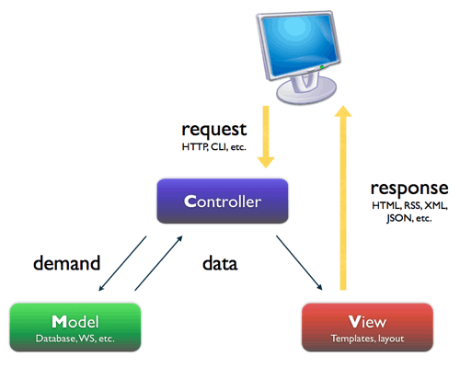

Figure 2(MVC Architecture)

An operating system for smartphones and other devices, developed by Android, Inc. and later purchased by Google. The Android platform is based on the Linux operating system, and features numerous apps developed by Google and by third-party developers.

**Apache**

HTTP server Apache Web Server is an open source Web server creation, deployment and management software. Initially developed by a group of software programmers, it is now maintained by the Apache Software Foundation.

As of 2013, with over 100 million websites and over 50 percent of the global market share, Apache Web Server is one of the most commonly used applications for website hosting.

**JavaScript**

JavaScript is the one of the language. It is use to develop the web sites and software. Developers are use JavaScript to front-end and backend.It is a small and lightweight language. Inside a host environment (for example, a web browser), JavaScript can be connected to the objects of its environment to provide programmatic control over them. It is object-oriented language.

**JavaScript framework**

Once get JavaScript framework. They have jQuery and etc. when we using this kind of JavaScript frameworks. We should reduce the working time and easy to use the component because of OOP concept.

[**ReactJS**](http://blog.andrewray.me/reactjs-for-stupid-people/)

A React.js developer specializes in building high-performance UI components and apps, especially those that need to juggle lots of dynamic content changing within the view (think Facebook or Instagram). On the front-end they use a combination of HTML, CSS, and JavaScript to build everything a user sees and interacts with on a website.

**MySQL**

MySQL is the world's most popular open source database software. With its superior speed, reliability, and ease of use, MySQL has become the preferred choice for Web, Web 2.0, SaaS, ISV, Many of the world's largest and fastest-growing organizations use MySQL to save time and money powering their high-volume Web sites, critical business systems, and packaged software including industry leaders such as Yahoo!, Alcatel-Lucent, Google, Nokia, YouTube, Wikipedia, and Booking.com

## **2.3 Tools**

**Sublime Text.**



Sublime Text is a cross-platform source code editor with a Python application programming interface (API). It natively supports many programming languages and markup languages, and its functionality can be extended by users with plugins, typically community-built and maintained under free-software licenses.

**WAMP Server**



WAMP Server refers to a software stack for the Microsoft Windows operating system, created by Romain Bourdon and consisting of the Apache web server, OpenSSL for SSL support, MySQL database and PHP programming language. There is Phpmyadmin. Using WAMP server we can create DB, and also, we can create some query too. And also, we can run our system using WAMP server.

## **2.4 Developments during the training period at Brand Centrical PVT(LTD).**

I was training as an PHP Developer in Brand Centrical PVT(LTD). Then I had to develop web application & web sites using PHP. I worked at the below projects.

* Alaris
* Tropical Vacation
* Medex
* BCkonnect
* Ebert Silva
* Bc portal

**Alaris**

This is my first project that I joined in Brand Centrical PVT(LTD). Alaris is a web site. I build Alaris Web Site Backend.

Admin can

* Login.
* Add slider(add,edit,view,delete)
* Add users(add,edit,view,delete)
* Add news &media(multiple image upload,add edit, delete,view)
* Add product(add,edit,view,delete)

HR can

* Login.
* Add slider(add,edit,view,delete)
* Add news &media(multiple image upload,add edit, delete,view)
* Add product(add,edit,view,delete
* But hr can’t add user(User Privilege)

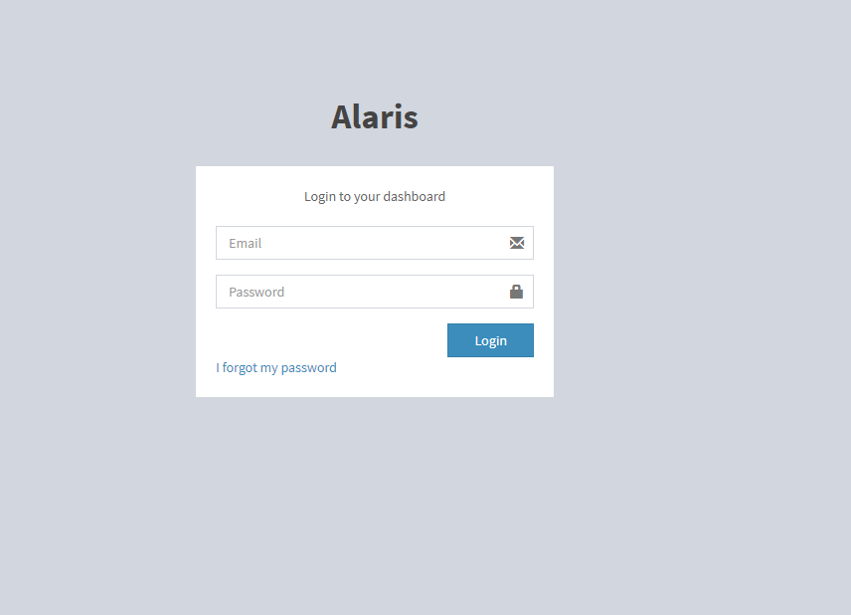

Figure (Alaris login)

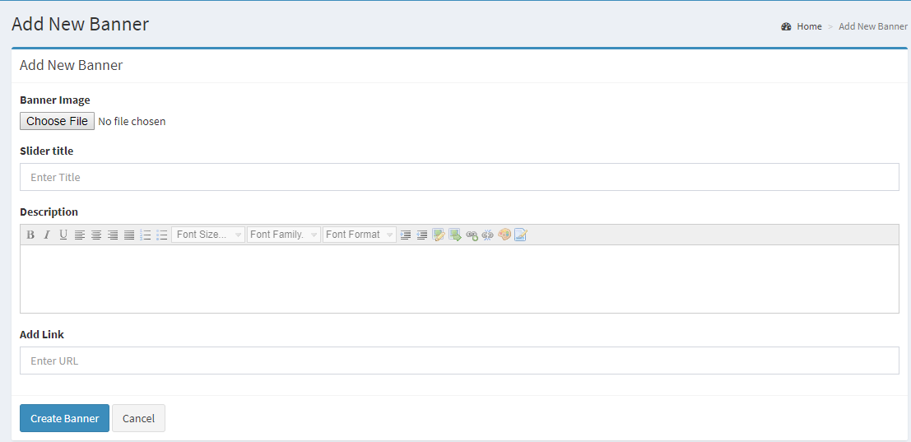

Figure (Add Slider)

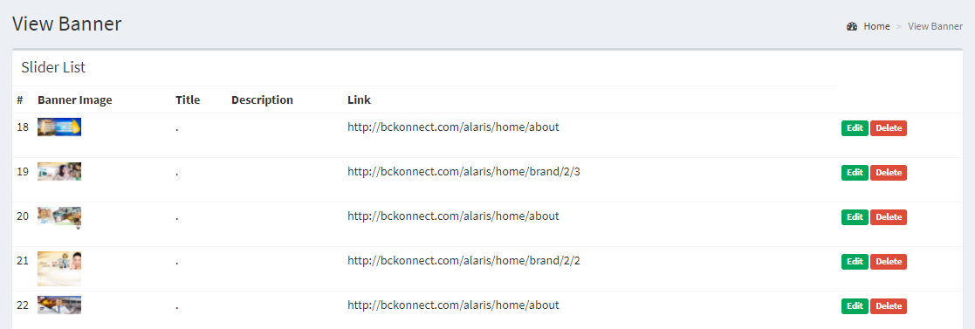

Figure (View, edit, delete, slider)

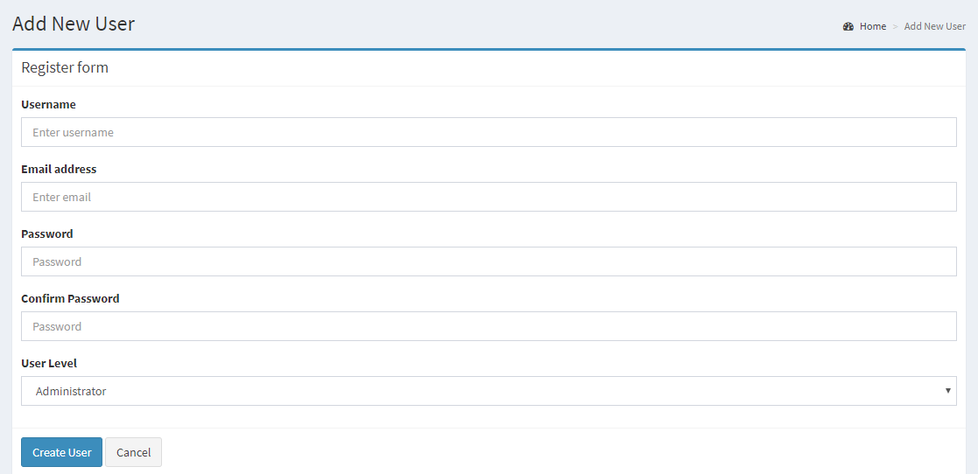

Figure (Add user)

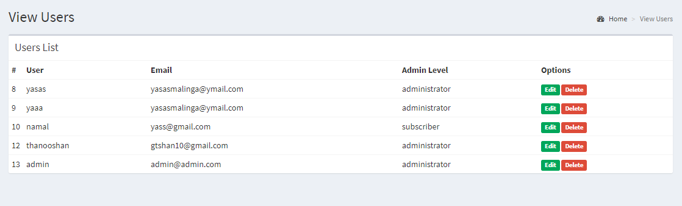

Figure (View, Edit, Delete user)

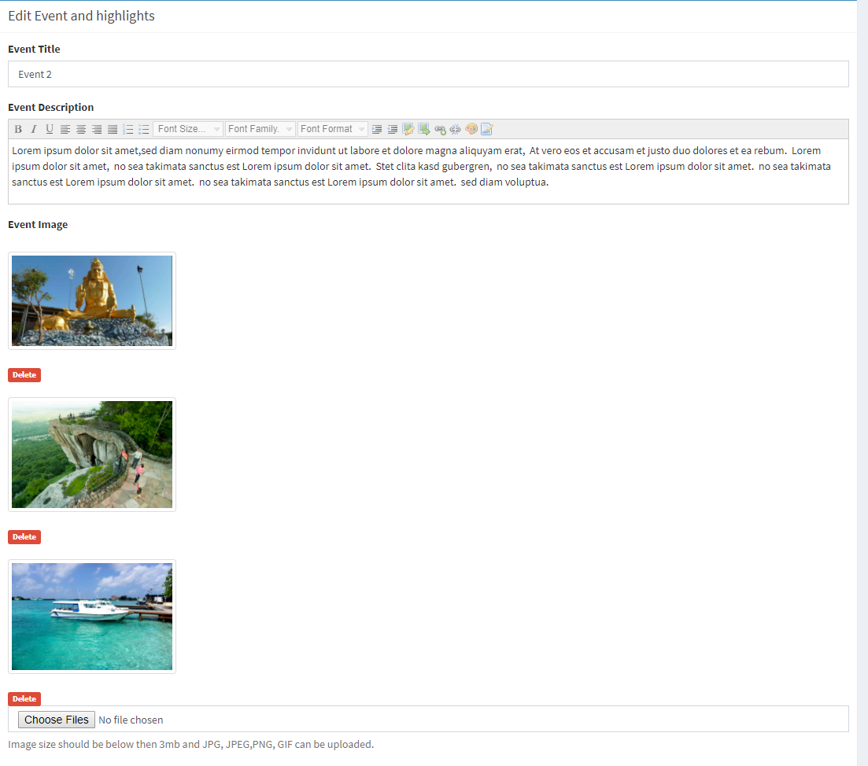

Figure (Multiple Images Upload)

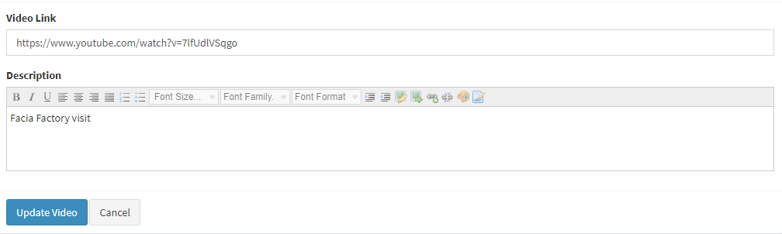

Figure (Home page Video Add)

**Tropical Vacation**

This is my Second project that I joined in Brand Centrical PVT(LTD). Tropical vacation is a web application. I build Alaris Tropical Vacation Web Application. It based on tourism.

Admin Can

* Login
* Create Customer(add,edit,delete)
* Add Destinations(add,edit,delete)
* Add Hotel (add,edit,delete)
* Add place(add,edit,delete)
* Add activity (add,edit,delete)
* Create PDF

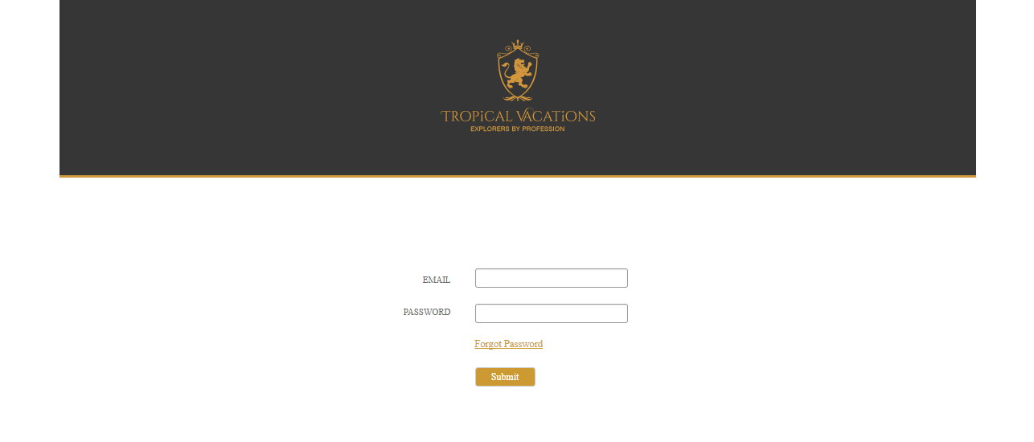

Figure (tropical vacation - login)

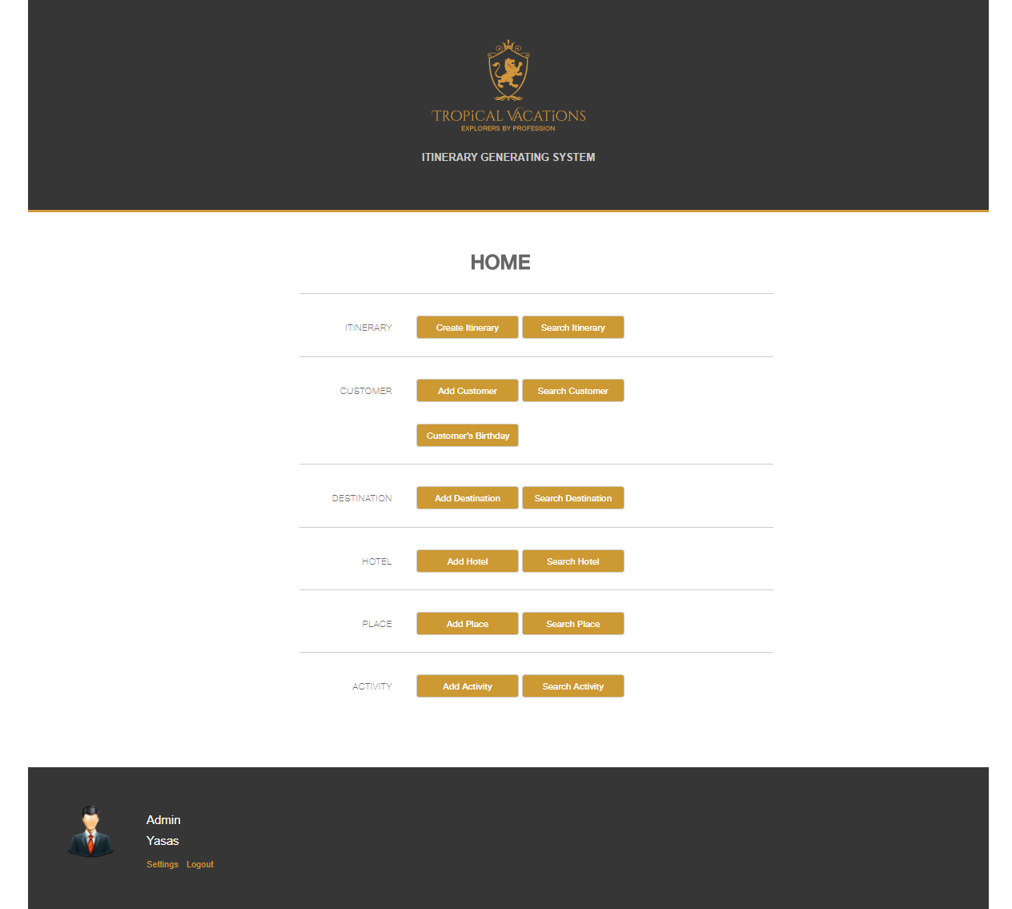

Figure (Home page)

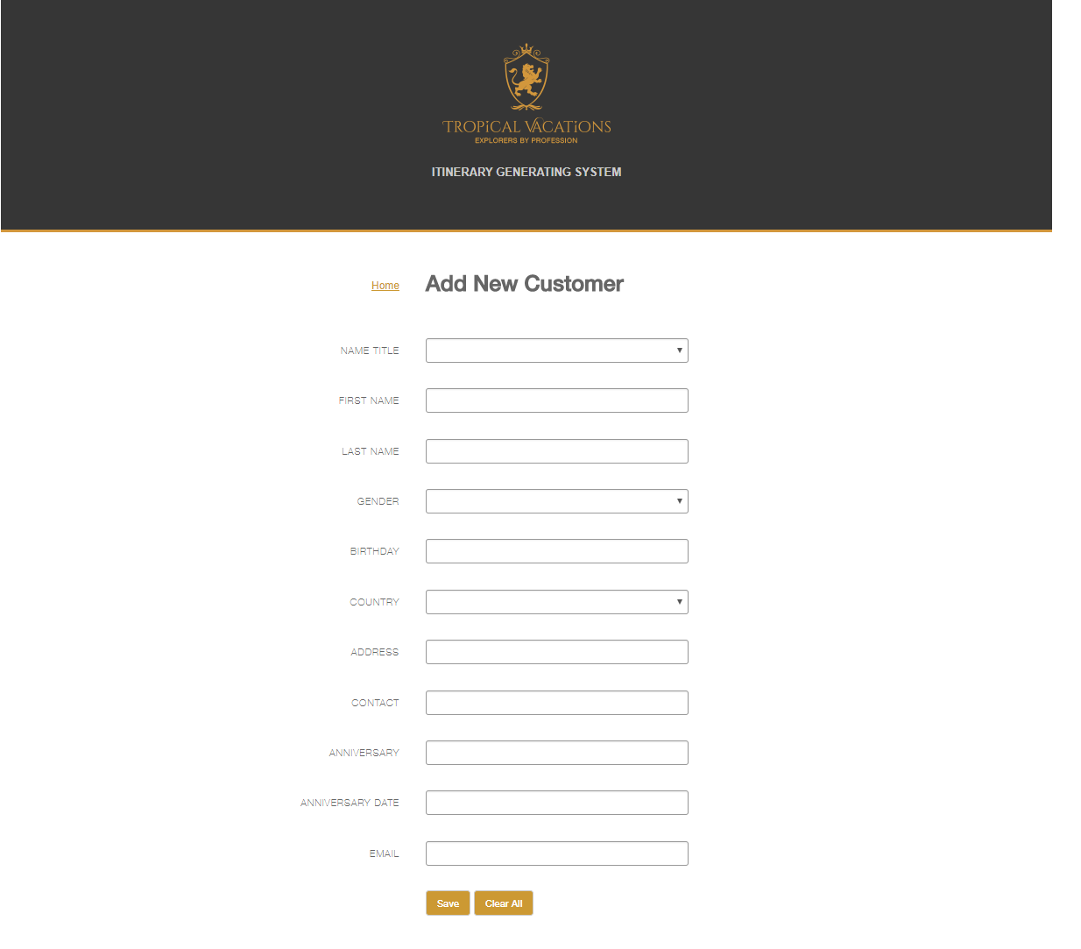

Figure (Add customer)

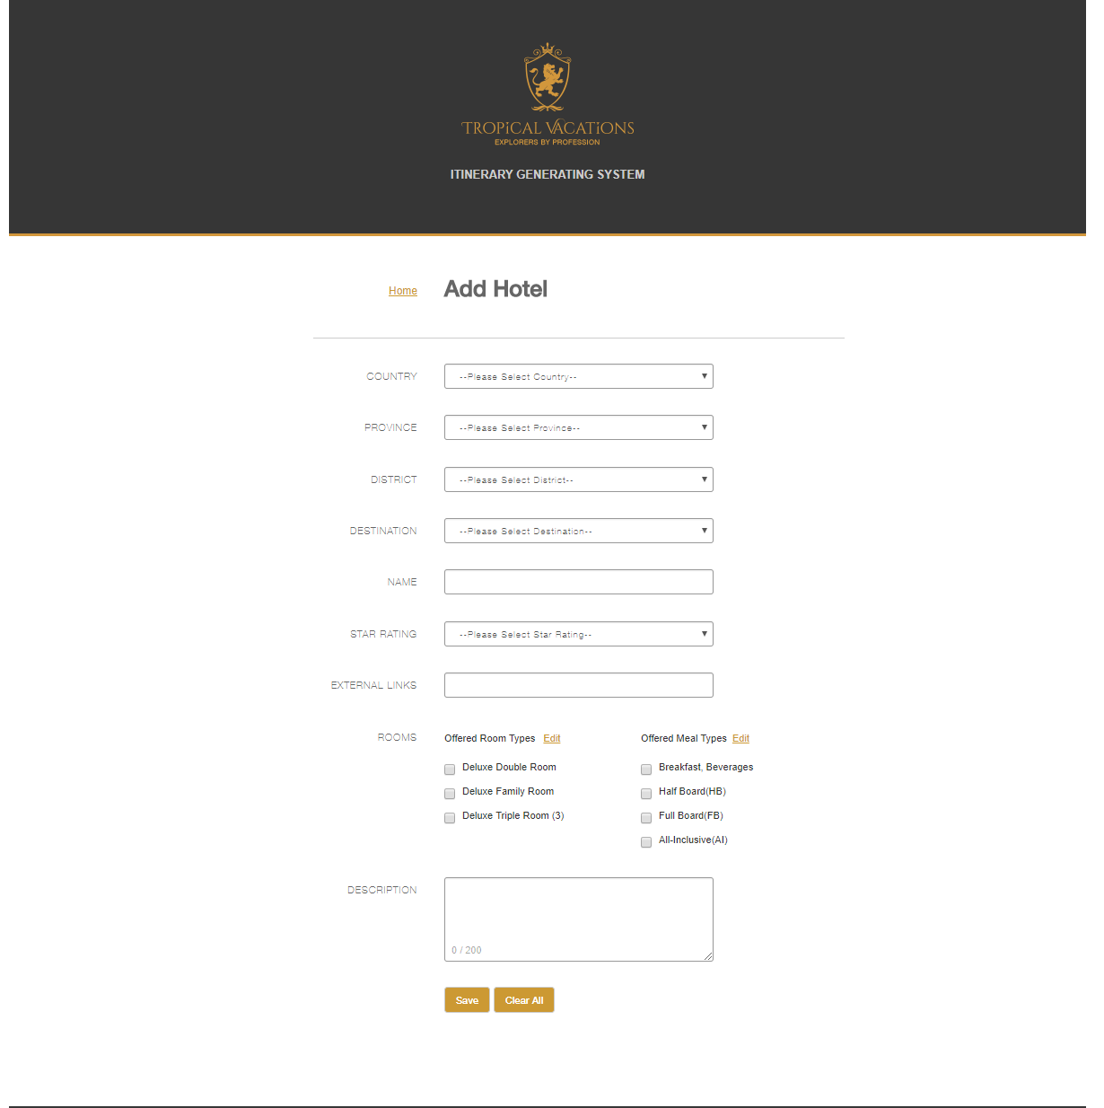

Figure (add hotel)

**Ebert Silva**

This is my third project that I joined in Brand Centrical PVT(LTD). Ebert silva is a WordPress web Site. I edit the theme. It based on travelling.

Admin can

* Change slider(add,edit,delete)
* Change homepage Video(add,edit,delete)
* Add destination
* Add Description
* Change images
* Etc

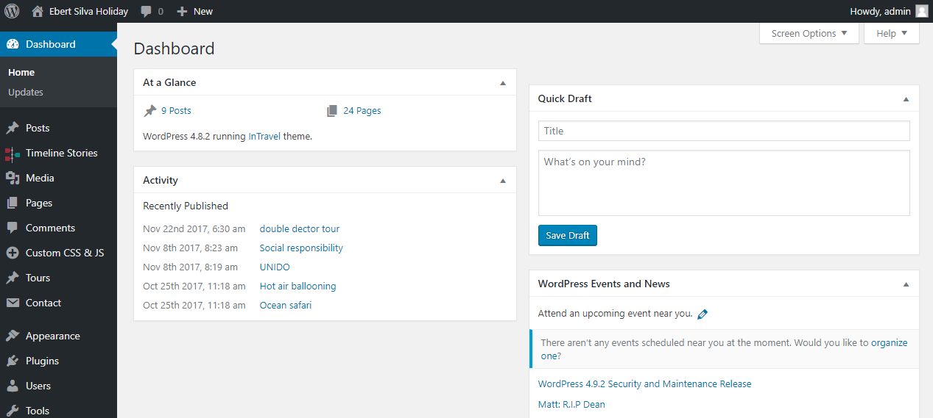

Figure (Admin panel Home page.)

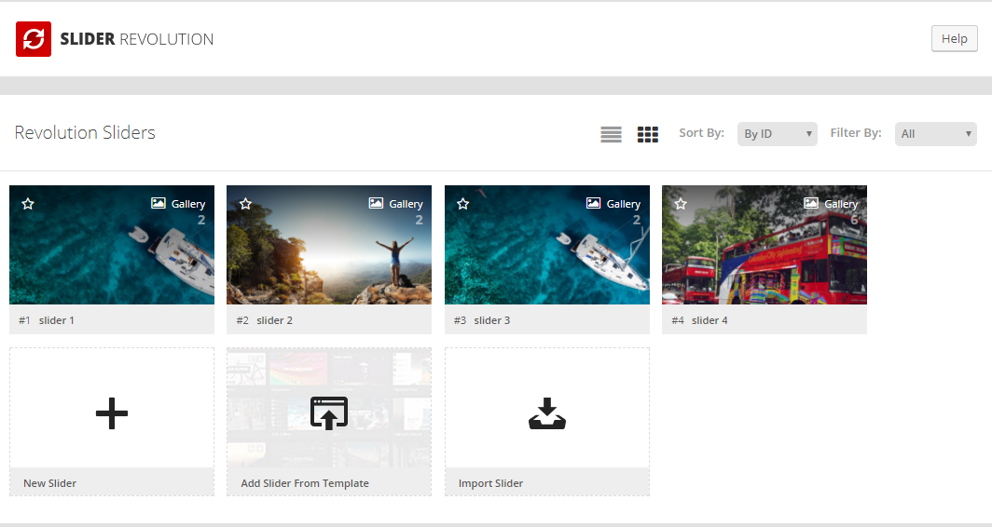

Figure (Change slider)

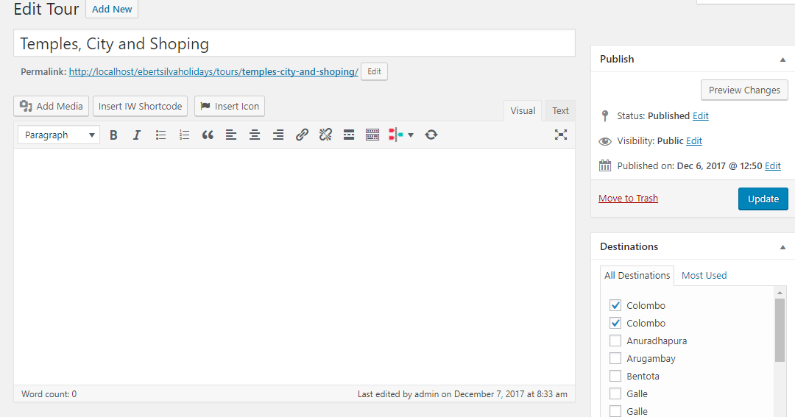

Figure (Add Description)

Bc portal

This is my another project that I joined in Brand Centrical PVT(LTD) .Bc Portal is a PHP(CodeIgniter ) web Application.

Admin can

* Login
* Create Role Management
* Create Employee Management
* View Leave Management
* View, Send Notice
* View Suggestion

Employee can

* Login (User Privilege)
* Send Leave
* Send Suggestion

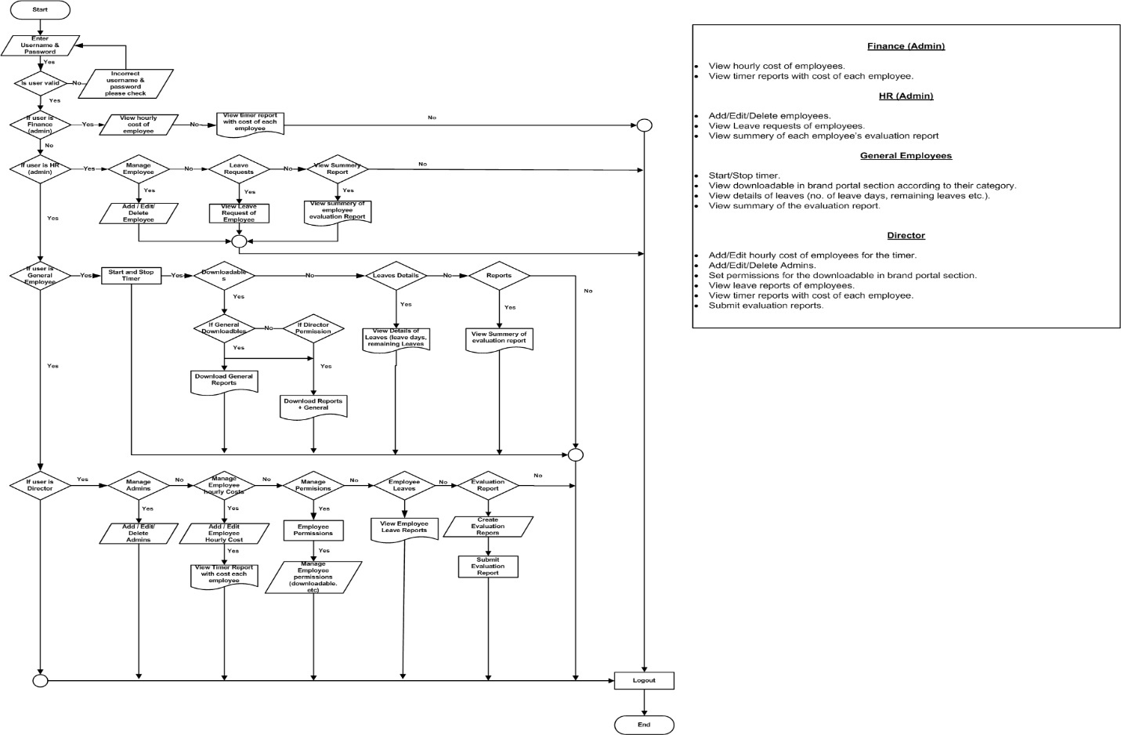

Figure 17(Bc Portal Flow Chart)

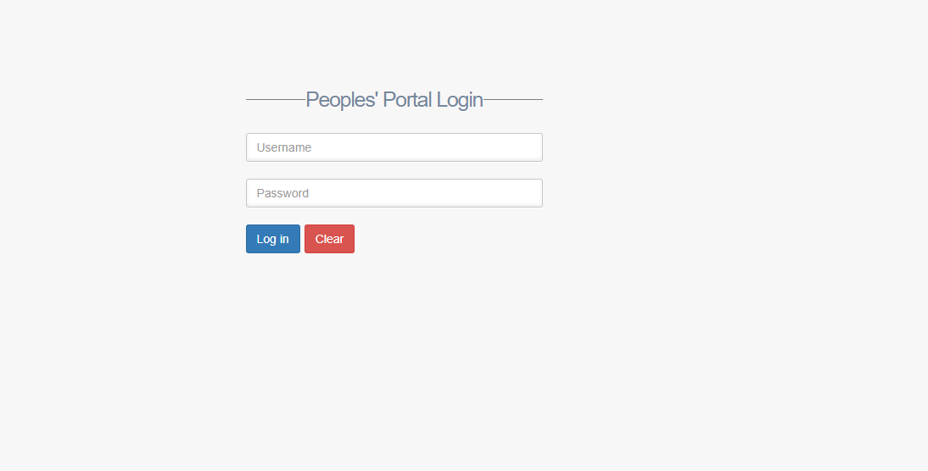

Figure 18(Bc portal Login)

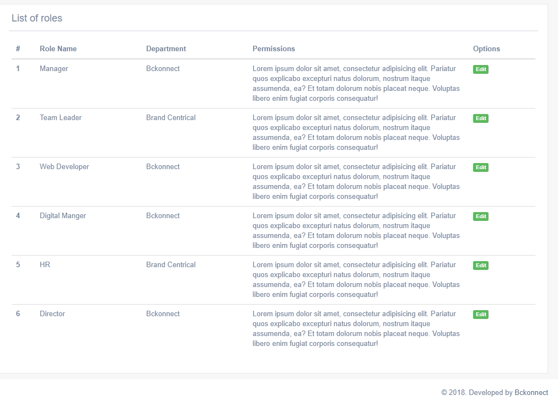

Figure 19(Role management)

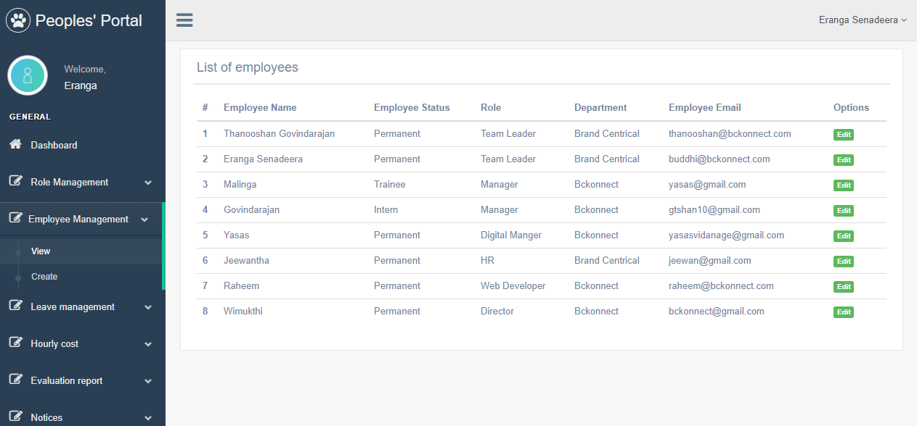

Figure 20(Employee Management)

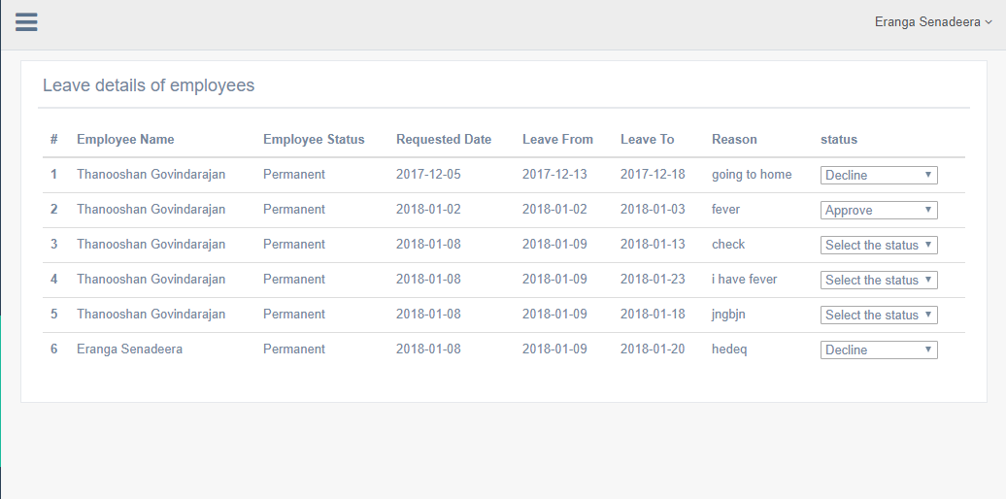

Figure 21(Leave Management)

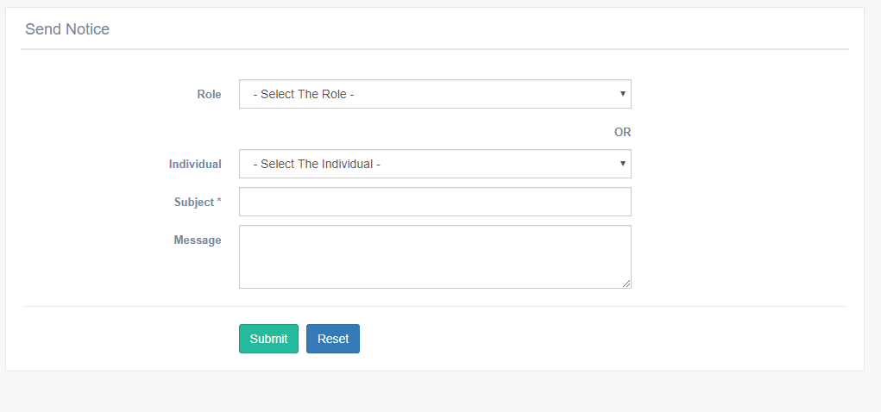

Send Notice

# **CHAPTER 03**

## **3 Conclusions**

Working with Brand Centrical PVT(Ltd) was a great opportunity to start my career life in Information Technology. As a Web developer, I got the training experience for six-months. Although I had learned about so many theoretical things in my academic period, there was no any idea about real world software products and technologies. I got the all experience about the industry. I also learnt about some common things like how to work in office environment, how to build relationships between each other, how to work under the senior officers and so on. My training period was a whole new learning experience with practice. Members of the officers are very helpful to me to enhance my knowledge. They always encourage me to learn new things and search things. And also, we have lot of thing to learn from this office. I am very lucky to work with such kind of friendly office members and pleasant office environment. They have been sharing their knowledge and experiences with new members and I got lot of things from them. It is a better to mention this few comments about ATI Galle and NAITA since it would be a great help for future enhancements of these training organizations.

### **3.1 Suggestions for improvement**

* I suggest that there should be increase the staff for efficiency work.
* It is better to give some industrial trainings for special persons to enhance quality of products.
* I suggest that change the company location with facilities.
* It is better to work with flexible hours for employees.
* It better to implement agile development for software projects.
* I suggest that introduce company branches.

### **3.2 Strengths and Weaknesses**

* I got very good knowledge about Web developments, some tools and technologies which were not familiar for me.
* I got experience in working environment.
* I have weaknesses with spoken English and also in English writing skill.
* Faced some Problem that received information in delay.

# **4. References**

Coolbit Software Solutions (Pvt) Ltd. 2018. Software Development Company in Sri Lanka | Coolbit. [ONLINE] Available at: <http://www.css.lk/>. [Accessed 20 January 2018].

Penzu. 2018. How to Write a Reflective Journal with Tips and Examples | Penzu. [ONLINE] Available at: <https://penzu.com/how-to-write-a-reflective-journal>. [Accessed 20 January 2018].

Wikipedia. 2018. Wikipedia. [ONLINE] Available at: [http://www.wikipedia.org/.](http://www.wikipedia.org/.%20) [Accessed 20 January 2018].